Rameet Sandhu

Justin Jaunay

Chad Stone

Santino Milan

Nicholas Jurgens

Hongni Liu

**Project Phase 3**

Table of Contents

*Part i: Create a GANTT Chart and PERT Chart*

*Part I: User Manual for Software Module*

*Part II: High-Level Strategies for Each Driver*

*Part III: SC Management Guide*

*Part IV: Transportation Networking and the Facilities*

***Part i: Create a GANTT Chart and PERT Chart***

Define the Problem:

* Define the role of each member

Plan:

* Create a activity matrix
* Create a GANTT chart
* Create a PERT chart

Execute:

* Activity Matrix:

1. Cycle Inventory
2. Demand Forecasting
3. Software
4. Transportation Network and Facilities
   1. X = “depends on”
   2. BxA = subtasks B depends on subtask A

|  |  |  |  |  |
| --- | --- | --- | --- | --- |
|  | A | B | C | D |
| A | A |  |  |  |
| B |  | B |  |  |
| C | X |  | C |  |
| D | X | X | X | D |

* Create a GANTT chart

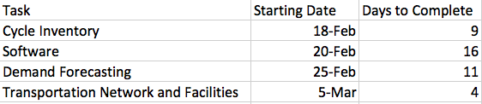

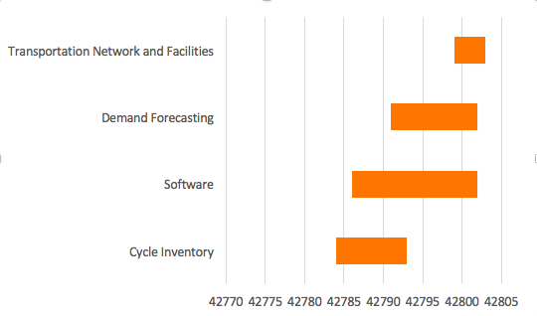

* Create a PERT Chart

***Part I: User Manual for Software Module Implemented***

1. **Define the Problem:**

a. Develop a user’s manual for your software module.

**II. Plan the Problem:**

i. Review all work done on Software Module

ii. Explain how a new user would use the software and explore all the functions using:

1. Screenshots of the Software
2. Excel sheets
3. Explain into detail how to use the software

**III. Execute the Plan:**

**Step 1:**

1. Open up excel spreadsheet to sheet 1.
2. Write Period t in Cell A1
   1. Below list the number of period
   2. Add the periods to be forecasted
3. Write Demand dt B1
   1. Below list the numbers for the demand



1. Click on the “Launch App Button”
2. Displays the “Demand Forecasting Main Menu” window

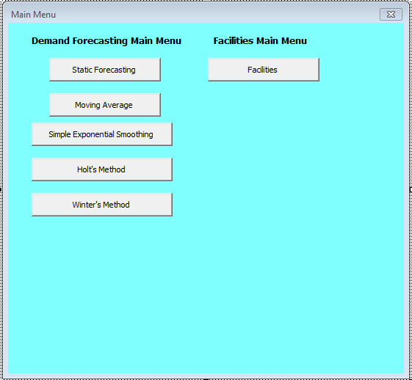

1. Demand Forecasting Main Menu:
   1. Static Forecasting Button: Click to perform Static Forecasting
      1. Back button goes back to the demand forecasting screen
      2. Once all the text box are filled Press Forecast to fill the excel sheet with static forecasting
      3. Next button moves to Cycle inventory page

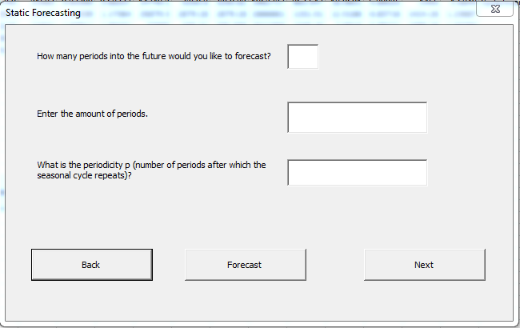

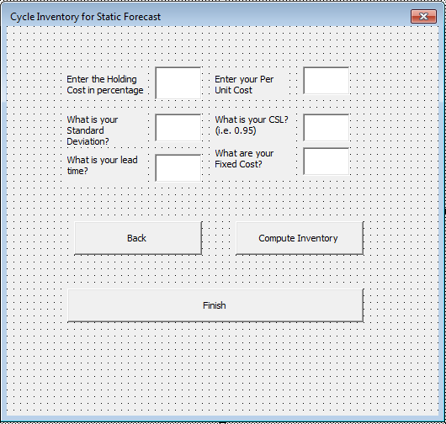

* + 1. Once the next button has been clicked
       1. Back button takes you back to the static forecasting screen
       2. Fill out Information and click Compute Inventory
       3. Finish Button terminates the VBA launch
  1. Moving Average Button: Click to perform Moving Average Forecasting method
     1. Back button goes back to the demand forecasting screen
     2. Once all the text box are filled Press Forecast to fill the excel sheet with moving average forecasting
     3. Next button moves to moving average page

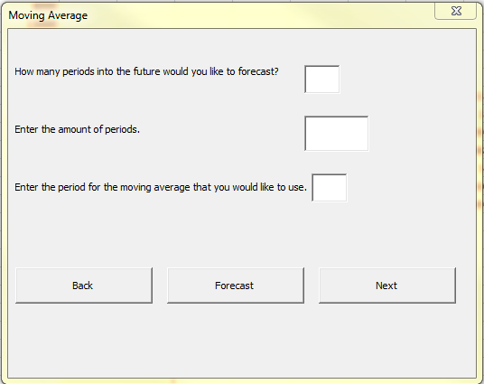

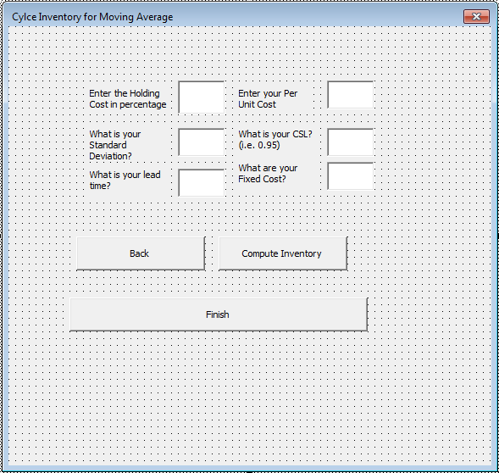

* + 1. Once the next button has been clicked
       1. Back button takes you back to the moving average screen
       2. Fill out Information and click Compute Inventory
       3. Finish button terminates the VBA page
  1. Simple Exponential Smoothing Button: Click to perform Simple Exponential Smoothing forecasting method
     1. Back button goes back to the demand forecasting screen
     2. Once all the text box are filled Press Forecast to fill the excel sheet with exponential smoothing forecasting
     3. Next button moves to simple exponential smoothing page

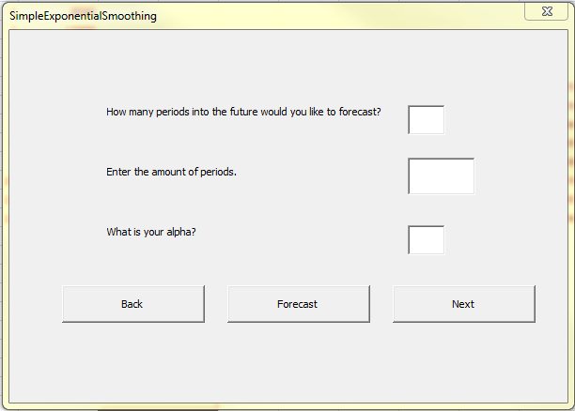

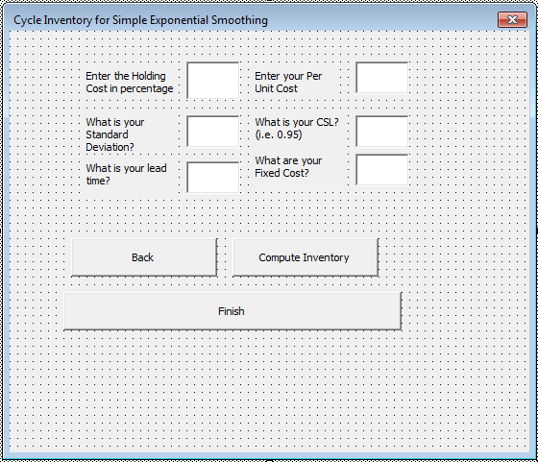

* + 1. Once the next button has been clicked
       1. Back button takes you back to the simple exponential smoothing screen
       2. Fill out Information and click Compute Inventory
       3. The Finish button terminates the VBA page
  1. Holt’s Method Button: Click to perform Holt’s method of forecasting
     1. Back button goes back to the demand forecasting screen
     2. Once all the text box are filled Press Forecast to fill the excel sheet with holt’s forecasting
     3. Next button moves to holt’s method page

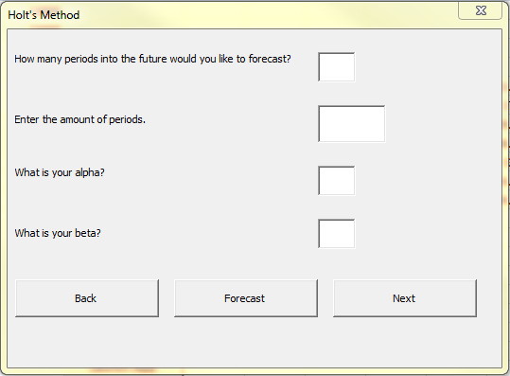

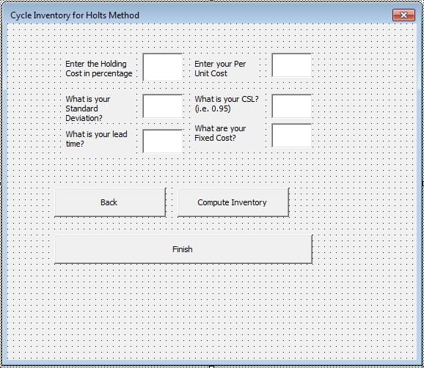

* + 1. Once the next button has been clicked
       1. Back button takes you back to the holt’s method screen
       2. Fill out Information and click Compute Inventory
       3. Finish Button terminates the VBA page
  1. Winter’s Method Button: Click to perform Winter’s method of forecasting
     1. Back button goes back to the demand forecasting screen
     2. Once all the text box are filled Press Forecast to fill the excel sheet with winter’s forecasting
     3. Next button moves to winter’s method page

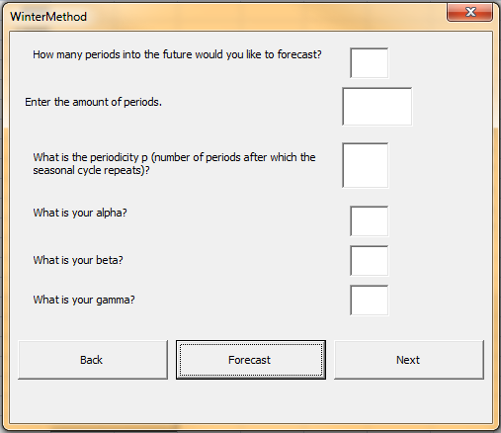

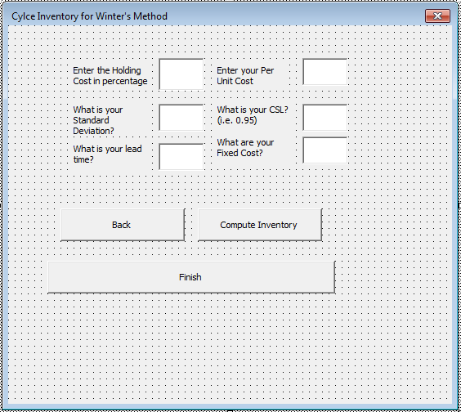

* + 1. Once the next button has been clicked
       1. Back button takes you back to the winter’s method screen
       2. Fill out Information and click Compute Inventory
       3. Finish button terminates the VBA page

1. Facilities Main Menu

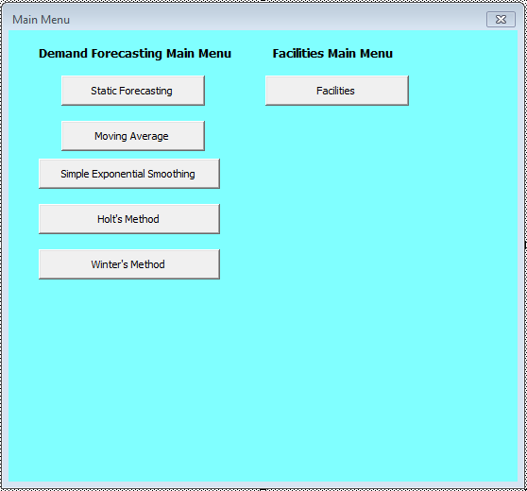

* 1. Before clicking facilities make sure to have a detailed graph for the Inputs of the Supply city and the Demand city’s . In addition to adding Fixed cost and capacity. Your table should look something like this: Please be sure to follow the example exactly, inputs, supply city, demand city, all need to be in the same location as the excel bellow. In addition do not merge cells as it will throw off the Visual Basics code.

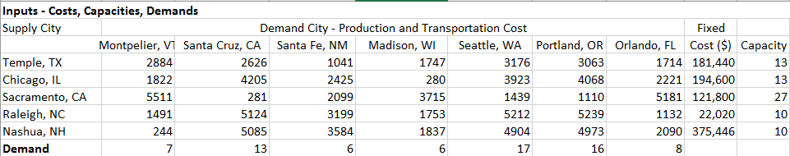

* 1. After making sure that the table is filled out click on the facilities button

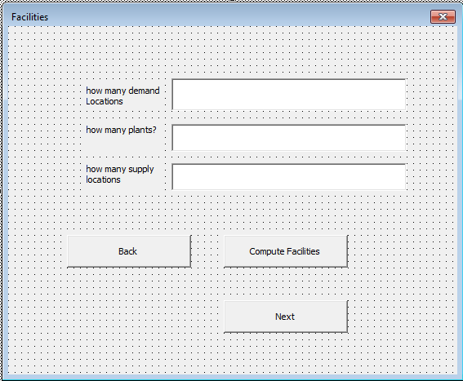

* + 1. Fill out how many demand locations by putting the number of cities at the top of the table (i.e. 7)
    2. Fill out how many plant there are (i.e 1)
    3. Fill out how many supply locations by putting the number of cities in that take part of the vertical axis (i.e 5)
       1. Back button brings you back to the main screen
       2. Compute Facilities computes the Facilities
       3. Next Brings you to the last page of Transportation

1. Transportation
   1. First give us a an excel sheet exactly like the one below, but you can add your own values

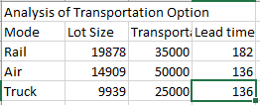

* 1. Click next on Facilities to access the Transportation page

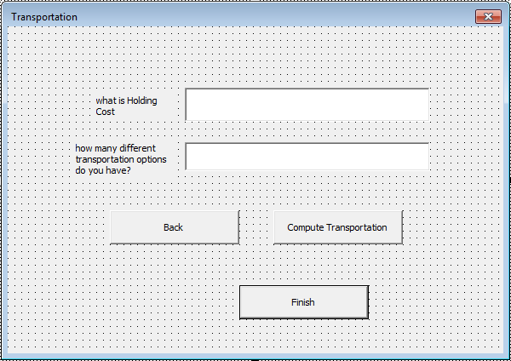

* 1. How many different transportation options do we have is equivalent to Rail Air Truck (i.e. 3)
     1. Back button takes you back to Facilities
     2. Compute Transportation computes transportation
     3. Finish ends the VBA code

***Static Demand Forecasting***

Plot demand actual data

* Calculate the deseasonalized demand
  + D2.5 = (D1+D2+D3+D4)/4
  + D3.5= (D2+D3+D4+ D5)/4
  + D3= (D2.5+D3.5)/2
* Calculate regressed deseasonalized demand
  + Y=9767x + 23517
* Calculate seasonal factor
  + Seasonal factor is calculated by dividing regressed deseasonalized demand by real demand
* Calculate average seasonal factor
  + The average seasonal factor is equal to the average of the seasonal factor of the same quarter of each year.
* Forecast and plot the result
  + The forecast is calculated by the regressed deseasonalized demand multiply by the average seasonal factor.
* Calculate error, absolute error, squared error, MAD, MAPE, and TS.

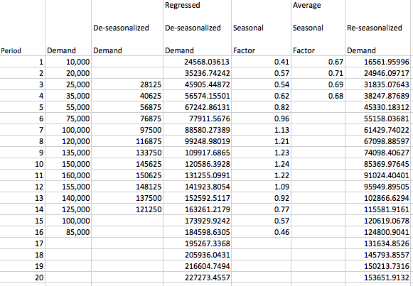

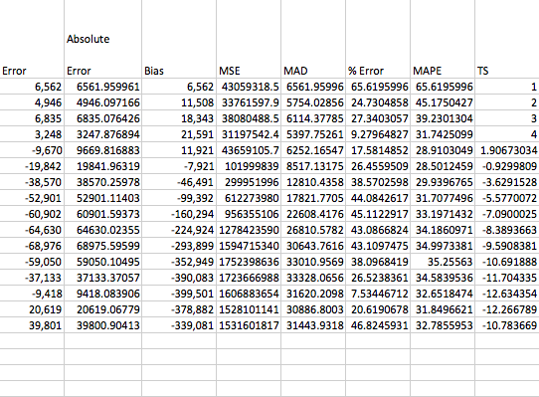

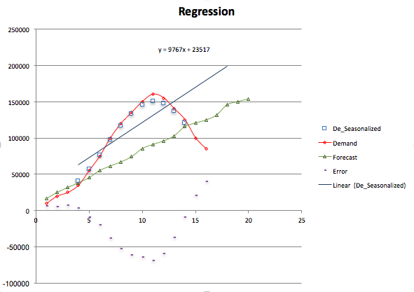

* Draw Conclusion:
* The errors are quite small. MAPE is around 28-40. TS is getting larger as the periods move on.

***Simple Exponential Smoothing***

* Assumption
  + The data has level L only
* Plot demand to the actual data
  + Calculate Lt
    - L0 = SUM(D1, Dn)/20=89,625.90
    - Lt+1 = α*Dt+1+(1- α)*Lt
* Forecast and plot the result
  + Ft+1 =Lt
* Calculate error, absolute error, squared error, MAD, MAPE, and TS

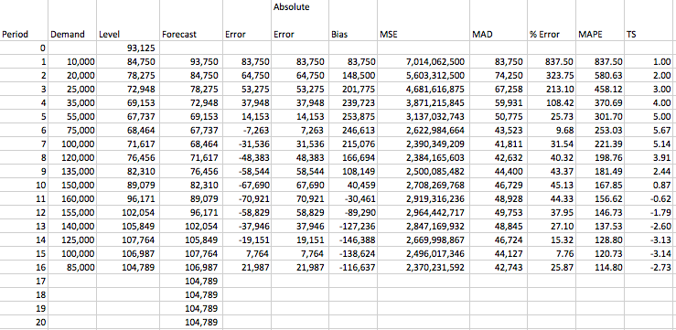

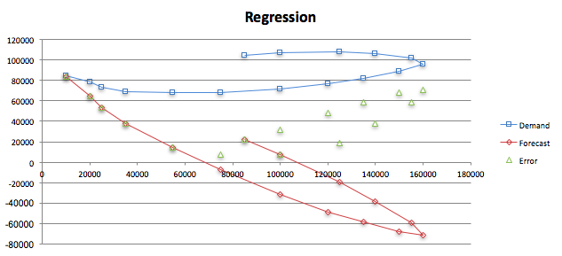

* Draw the conclusion:
  + The regression map for forecasting is going to a weird direction.

***Moving Average***

Assumption

* The data has level L only

Plot demand data

Calculate Lt

* Lt=(Dt+Dt-1+…+Dt-n+1)/N

Forecast and plot the result

* Dt=Lt-1

Calculate error, absolute error, squared error, MAD, MAPE, and TS.

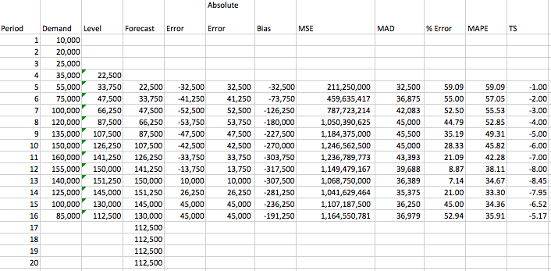

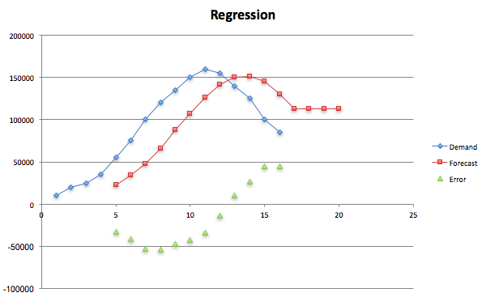

* Draw Conclusion:
  + MAPE is around 30-45，all TS are negative

***Holt’s Method***

* Assumption
  + Data has level L, trend T only
* Regress the given data to compute the initial value of L, and trend, T.
  + The initial level is 8088.2, and initial trend is 24375 after regression
* Use two smoothing constants, α and β to smooth respectively level L, and trend T.
  + Use α= 0.01, and β = 0.09
  + Lt+1 = α*Dt+1+(1- α)*(Lt+Tt)
  + Tt+1 = β *(Lt+1-Lt)+(1- β)*Tt
* Forecast
  + Ft+1 =Lt+Tt
* Calculate error, absolute error, squared error, MAD, MAPE, and TS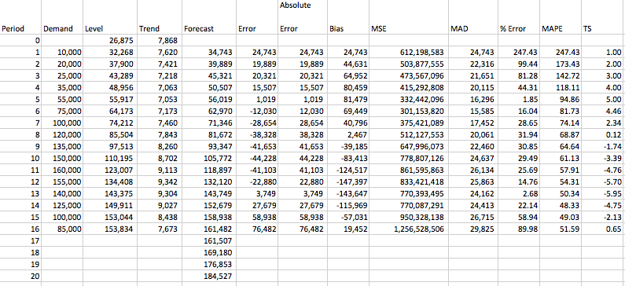

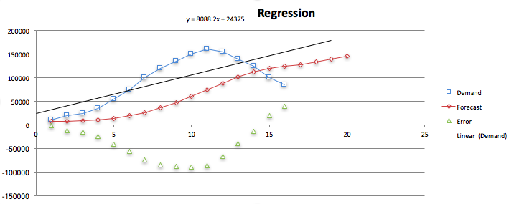

***Winter’s Method***

* Assumption
  + Data has level L, trend T, and seasonality.
* Initial the level L, trend T, and seasonality using static forecasting
  + From the static method, we get the initial level is 8088.2 and the initial T is 24375, and the four seasonal factors are 0.91, 0.61, 0.71, and 1.80
  + Use α= 0.01, β = 0.09, γ = 0.06
* Initialize forecast
* Adapt
  + Lt+1= α (Dt+1/St+1) + (1 - α)(Lt + Tt)
  + T1+1 = β (Lt+1- Lt) + (1- β)Tt
  + St+p+l = γ (Dt+l/Lt+I) + (1- γ)St+l
* Forecast
  + Ft+1 = (Lt+Tt)St+1
* Calculate error, absolute error, squared error, MAD, MAPE, and TS.

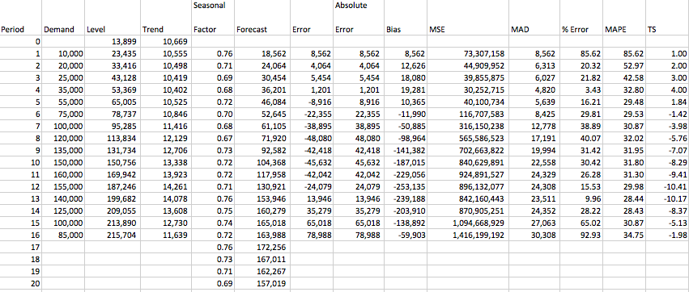

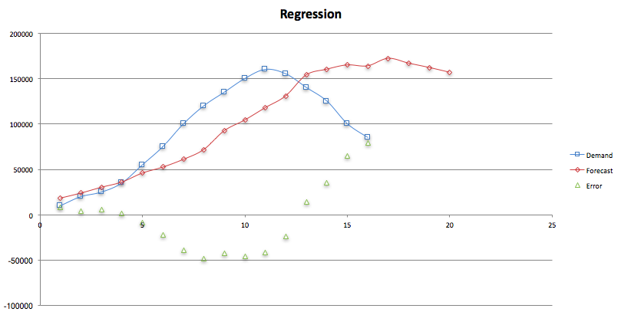

***Inventory Calculation***

**Part II: High-level Strategies for each Driver**

1. **Define the Problem:**
2. Align and integrate your high-level strategies with the detailed implementations of each driver.
3. **Plan the Treatment:**
4. Identify the high-level strategies involved with each driver.
5. Analyze process for each of the drivers to access the best strategy
6. **Execute the Plan:**

|  |  |
| --- | --- |
| ***Driver*** | ***Strategy*** |
| Inventory | * Our goal is to have low levels of inventory on hand to minimize cost to stay efficient. * Two types of inventory is used:   + Cycle Inventory: nominal inventory required to meet the average customer demand and annual customer demands   + Safety Inventory: Inventory that is kept to meet uncertainties in customer demand. * Our product isn’t an item that would be high in demand in the eyes of customers. It isn't a necessity so we can keep inventory low while also cutting cost. |
| Facilities | * We will have fewer facilities so we stay highly efficient keeping cost low like we had stated in phase 2 in our responsiveness/ efficiency spectrum. * Important considerations are:   + Location: We plan to keep our facilities close to our manufacturers therefore transporting our product from one facility to the next won't be a struggle.   + Function: Our layout will be organized and structured in a way that will make it easier for our customers to get their orders quickly and easily.   + Capacity: We will need big warehouses since our product will be large and consume a lot of space in the facility. |
| Transportation | * What modes of transportation the firm should use to get our product to customers the quickest and easiest?   + We believe that we should use land and air transportation.   + We can use trucks to ship to local areas within driving range of 500-1000 miles and use air transportation for those customers that are further so we can get our product to them quickly and efficiently. |
| Information | * We will be using information systems and information technology to make our supply chain both very responsive and very efficient. It will allow for easy accessible information so stages in the supply chain can run smoothly and be quickly fixed. |

**Draw Conclusion:**

We see how our drivers use high-level strategies to efficiently allow our product go through each stage and make it to our customer smoothly and quickly with no complications. Each stage is very important in order for our product to be processed and delivered to our customers.

**Part III: SC Management Guidelines**

**Define the Problem:**

* In this section, we will begin to set the guidelines for our SC management to follow.

**Plan the Problem:**

1. Research and plan the components necessary for your product.
2. List and provide a source for each of the aforementioned components.
3. Calculate cycle inventory.
4. Calculate safety inventory.
5. Conclude the section.

**Execute:**

Smart Trash can components:

* Steel body
  + We can build 100, 20 pound containers at approximately $500.
  + $5 per container.
  + <http://www.alibaba.com/product-detail/Galvanized-steel-Galvanized-sheet-Galvanized-Steel_60395626200.html?spm=a2700.7724838.0.0.mcanYX>

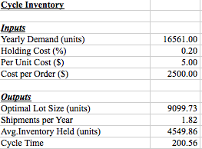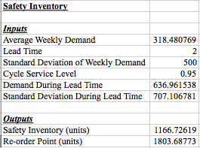

* + For each trashcan, we will put aside 20 pounds of stainless steel for the body of the trashcan. In this case, if we buy 5 tons of steel per order, we can make 500 trashcans per order.
  + Using the forecasted first year demand of our Static Forecasting model, we found the following cycle inventory numbers:
    - Our optimal lot size is 9.099 tons of steel per order.
    - Purchased every 201 days.
    - Per year, we’d make 1.82 orders.
  + **We used the following formulas in our calculations:**
    - Q* = √(2*D*S)/(hC)
    - Shipments per Year = (D/Q*)
    - Cycle Inventory (Avg. Inventory Held) = (Q*/2)
* Wifi Adapter
  + $6.15 per container.
  + <http://www.alibaba.com/product-detail/2016-New-Product-EDUP-EP-AC1619_60570468192.html?spm=a2700.7724838.0.0.o242ul&s=p>

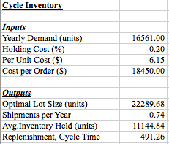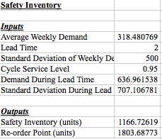

* + For each trashcan, we install a single Wifi adapter.
  + Using the forecasted first year demand of our Static Forecasting model, we found the following cycle inventory numbers:
    - Our optimal lot size is 22,289 units per order.
    - We’d place an order every 491 days.
    - Approximately .74 orders every year.
* Touch screen
  + $4 a container.
  + <http://www.alibaba.com/product-detail/HAORAN-hot-sale-small-size-2_1110487327.html?spm=a2700.7724838.0.0.ZmRtyv&s=p>

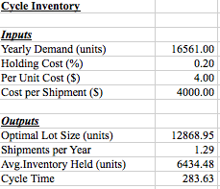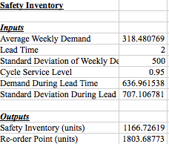

* + For each trashcan, we install a single touch screen.
  + Using the forecasted first year demand of our Static Forecasting model, we found the following cycle inventory numbers:
    - Our optimal lot size is 12,868.95 units per order.
    - This works out to a cycle time of about 284 days between orders.
    - We’d place approximately 1.29 shipments per year.
* Electronic Scale
  + $2 a container.
  + <http://www.alibaba.com/product-detail/Digital-Electronic-Jewelry-Scale-Food-Scale_60565596532.html?spm=a2700.7724838.0.0.uwWW4i>

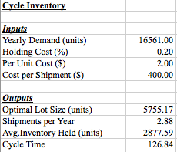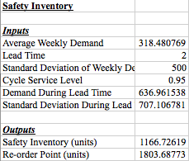

* + For each trashcan, we install a single electronic scale.
  + Using the forecasted first year demand of our Static Forecasting model, we found the following cycle inventory numbers:
    - Our optimal lot size is 5,755 units per order.
    - We’d place an order every 126 days.
    - Approximately 2.88 orders every year.
* Proximity Sensor
  + $1 a container.
  + <http://www.alibaba.com/product-detail/Hot-new-M12-Inductive-Proximity-Sensor_323925717.html?spm=a2700.7724838.0.0.kzphMK>

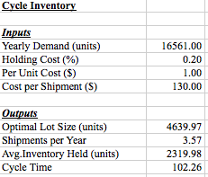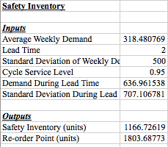

* + For each trashcan, we install a single proximity sensor adapter.
  + Using the forecasted first year demand of our Static Forecasting model, we found the following cycle inventory numbers:
    - Our optimal lot size is 4639 units per order.
    - We’d place an order every 102 days.
    - Approximately 3.57 orders per year.
* Circuit board
  + $4 a container.
  + <http://www.alibaba.com/product-detail/2017-ATX-Motherboard-H61-LGA-1155_60400316912.html?spm=a2700.7724838.0.0.UTeuef>

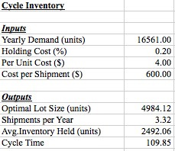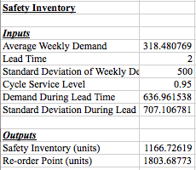

* + For each trashcan, we install a single circuit board.
  + Using the forecasted first year demand of our Static Forecasting model, we found the following cycle inventory numbers:
    - Our optimal lot size is 4984 units per order.
    - Our cycle time comes out to 110 days between orders.
    - Approximately 3.32 shipments per year.

**Conclusion:**

* In this section, we compiled all of the necessary components needs in the manufacturing of our product.
* After listing the individual components, we then found appropriate suppliers for each of these pieces.
  + This provided the basis for future calculations. (Cost per shipment etc.)
* Using the aforementioned numbers, we were able to calculate the cycle inventory for each component:
  + We calculated cycle time, which tells us how often to place an order.
  + We calculated the optimal lot size, which tells us how big of an order to place.
* This gave us a guide towards how to purchase everything

**Part IV: Transportation Networking and the Facilities**

**Define the Problem:**

* Design and implement the transportation networking and the facilities

**Plan the Treatment:**

* Describe multiple transportations in supply chain management
  + Draw the transportation network
  + Implement the transportation networking
* List the facilities

**Execute the Plan:**

Describe the modes of transportations in supply chain management

* Draw the transportation network



* Implement the transportation networking
  + Manufacturing in Mexico
    - From the phase 1, 2, and TIM 105 Final Project, we discussed that manufacturing our product in Mexico would be a good choice. The price of delivering products to customers is around $235/container.
      * <http://acetool.commerce.gov/shipping>
    - The mode of transportation that we are going to choose is surface and the containers will go through by road and rail.
      * Road, trucks:
        + Advantages:

relatively cheap

Flexible

* + - * + Limits:

Limited carrying capacity

Not economical for long distance and heavy goods

* + - * Rail:
        + Advantages

Faster than truck

Cost effective for carrying heavy goods in long distances

* + - * + Limits:

Not available in remote parts of the country

Not flexible

* + Manufacturing in China
    - We also discussed what if we manufacture our products in China because China has the lowest manufacture cost.
    - The modes of transportation are going to be air or water
      * Air:
        + Advantages:

Fastest delivery

Improved service levels

* + - * + Limits:

High cost

Not suitable for heavy goods

* + - * Water:
        + Advantages:

Cost efficient

* + - * + Limits:

Dangerous while trading, i.e. depth water, weather condition

Long time

List facilities:

* If we manufacturing from Mexico, then all the possible transportation costs for trucks and rails are:
  + Road:
    - Development costs: $10M (from the previous stats)
    - Construction costs:
    - Maintenance costs: unknown
    - Administration costs:
    - Losses in land taxes: depends between states
    - Expropriation costs:
    - External costs (accident and pollutions): unknown
  + Rail:
    - Development costs: $10M
    - Construction costs:
    - Administration costs:
    - Terminal costs:
    - External costs: lower than road
* If we manufacturing from China, then all the possible transportation costs for air and water are
  + Air:
    - Development costs: $10M
    - Construction costs:
    - Administration costs:
    - Service costs: high
    - Terminal costs:
  + Water:
    - Maintenance cost:
    - Capital cost:
    - Registration fee: low
    - Operating cost: low

**Draw the Conclusion:**

If we decide to manufacture in Mexico then we prefer road > rail because since our company is new, we don’t have a really large amount of goods that need to be deliver. If we decide to manufacture in China then we prefer water > air because water is a lot more cost efficient.